Oppgave 7 vurdering 2

OPPGAVE 6

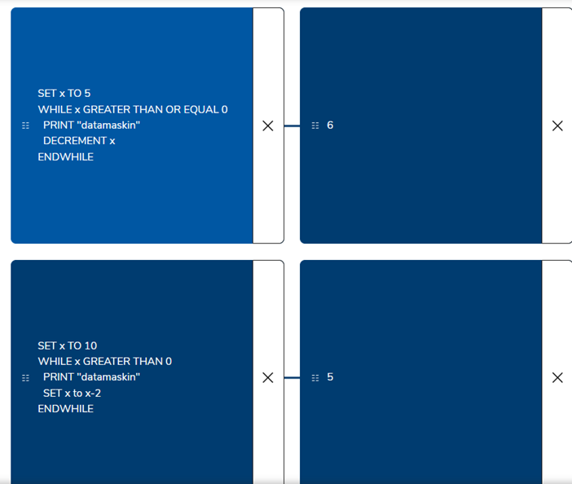

OPPGAVE 7

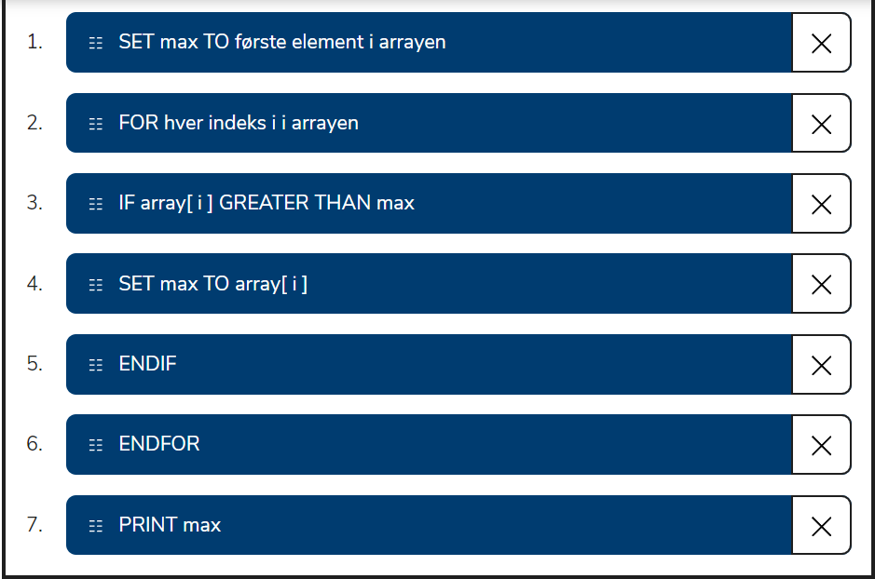

Oppgave 9

d) oppgaven ligger i python filen.

Veldig forvirrende hva man skal gjøre. Gjorde de lignende oppgavene fra linken. Oppgave 8-9 fra din word fil finnes ikke på udir, og de har en annen oppgave 8.